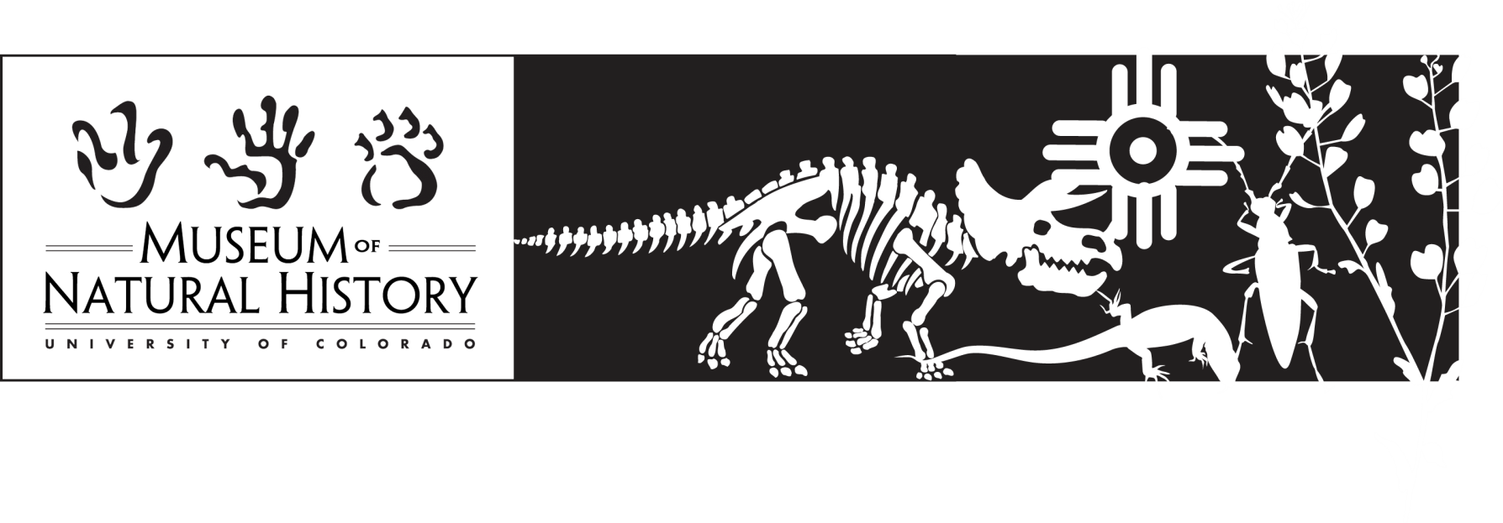

**Additional Resources for the Insect Explorers guided program**

For more information about the Museum, our collections, and exhibitions, visit our web site at <http://cumuseum.colorado.edu>

CU Museum Discovery Kits – check out our Discovery Kit “Insects” that can add to your program/workshop experience. A list of available kits and cases along with photos and inventory lists are on our web site.

Web sites:

<http://outreach.colorado.edu/programs/p12> The University of Colorado’s web site for outreach activities offered by the University.

<http://www.pbs.org/wgbh/nova/teachers/> The PBS NOVA website for teachers.

<http://smithsonianeducation.org/educators/index.html> The Smithsonian Institution website for educators.

<http://teacher.scholastic.com/activities/bugs/> A Scholastic web site that includes a teacher’s guide for Going Buggy, and Bug and Insect Information.

<http://ghopclimate.colorado.edu/> The CU Museum’s “Grasshoppers and Climate Change” web site featuring the Gordon Alexander Grasshopper Collection.

<http://puzzlemaker.discoveryeducation.com/> A website where you can easily create your own crossword puzzles or word searches using the listed vocabulary words.