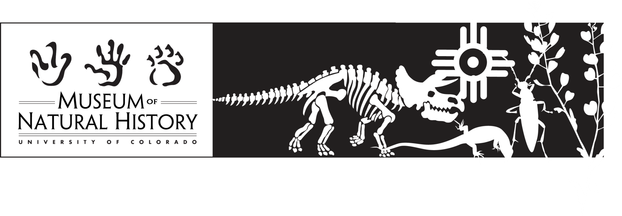

**Additional Resources for the Colorado Animals and Plants**

**guided program and workshop**

For more information about the Museum, our collections, and exhibitions, visit our web site at <http://cumuseum.colorado.edu>

CU Museum Discovery Kits – check out these Discovery Kits that can add to your tour/workshop experience: “Bats,” “Insects,” “Colorado Mammals,” “Dinosaurs,” “Fossils of the West,” “Owls,” and “Raptors.” Also check out our Bird and Mammal Cases. A list of available kits and cases along with photos and inventory lists are on our web site.

Web sites:

<http://outreach.colorado.edu/programs/p12> The University of Colorado’s web site for outreach activities offered by the University.

<http://www.pbs.org/wgbh/nova/teachers/> The PBS NOVA website for teachers.

<http://smithsonianeducation.org/educators/index.html> The Smithsonian Institution website for educators.

<http://www.amnh.org/ology> The American Museum of Natural History’s Ology site for kids and families. Includes information, activities, and much more

<http://magma.nationalgeographic.com/ngexplorer/0309/quickflicks> National Geographic quick flick movie on food chains.

<http://puzzlemaker.discoveryeducation.com/> A website where you can easily create your own crossword puzzles or word searches using the listed vocabulary words.